Lab report no : o6

Name of the lab report: Linux command for process

objectives:
- How to Manage Processes from the Linux Terminal?
- Run the following process commands in Linux.
Top, htop, Ps, pstree, kill, pgrep, pkill ,killall, renice, xkill,

How to Manage Processes from the Linux Terminal:

The Linux terminal has a number of useful commands that can display running processes, kill them, and change their priority level. Many of the commands here perform a single function and can be combined — that’s the Unix philosophy of designing programs. Other programs, like htop, provide a friendly interface on top of the commands.
Processes can be manage from the Linux terminal using the below commands:
- top.
- Htop
- ps
- pstree
- kill
- pgrep
- pkill & killall
- renice
- xkill

top
The top command is the traditional way to view your system’s resource usage and see the processes that are taking up the most system resources. Top displays a list of processes, with the ones using the most CPU at the top.
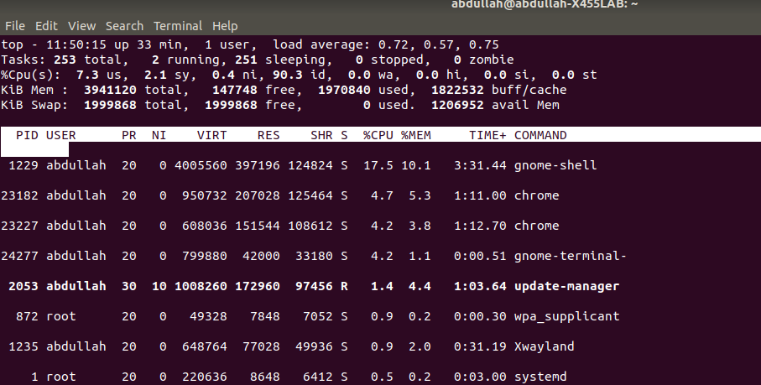

htop
The htop command is an improved top. It’s not installed by default on most Linux distributions — here’s the command you’ll need to install it on Ubuntu:
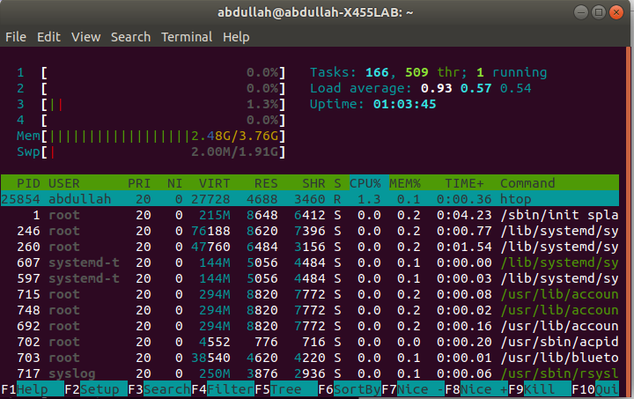

ps
The ps command lists running processes. The following command lists all processes running on your system:
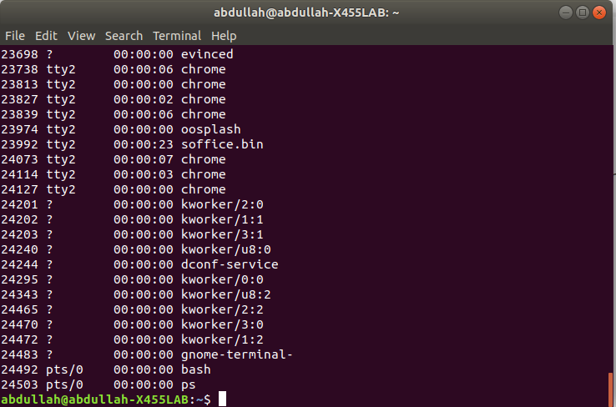

pstree
The pstree command is another way of visualizing processes. It displays them in tree format. So, for example, your X server and graphical environment would appear under the display manager that spawned them.
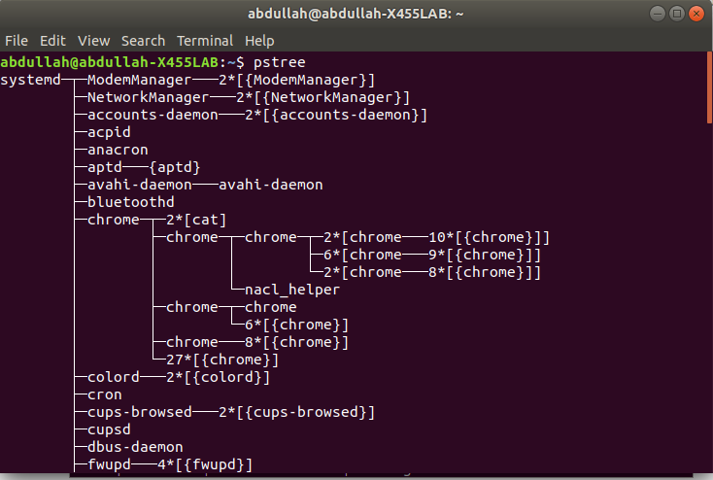

kill
The kill command can kill a process, given its process ID. You can get this information from the ps -A, top or pgrep commands.
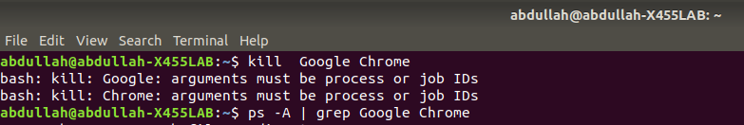

pgrep
Given a search term pgrep returns the process IDs that match it. For example, you could use the following command to find bash PID:
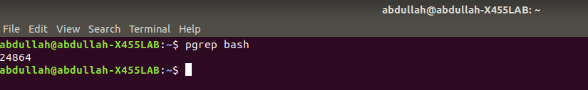

pkill & killall
The pkill and killall commands can kill a process, given its name.
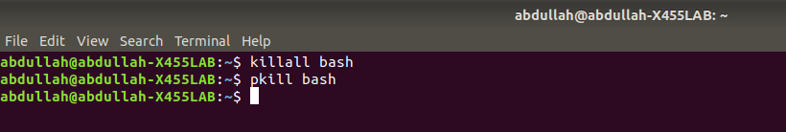

renice
The renice command changes the nice value of an already running process. The nice value determines what priority the process runs with. A value of -19 is very high priority, while a value of 19 is very low priority. A value of 0 is the default priority.
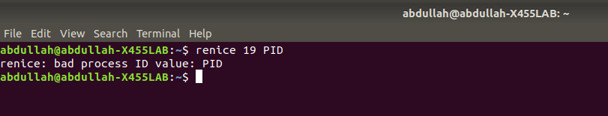

xkill
The xkill command is a way of easily killing graphical programs. Run it and your cursor will turn into an x sign. Click a program’s window to kill that program. If you don’t want to kill a program, you can back out of xkill by right-clicking instead.
